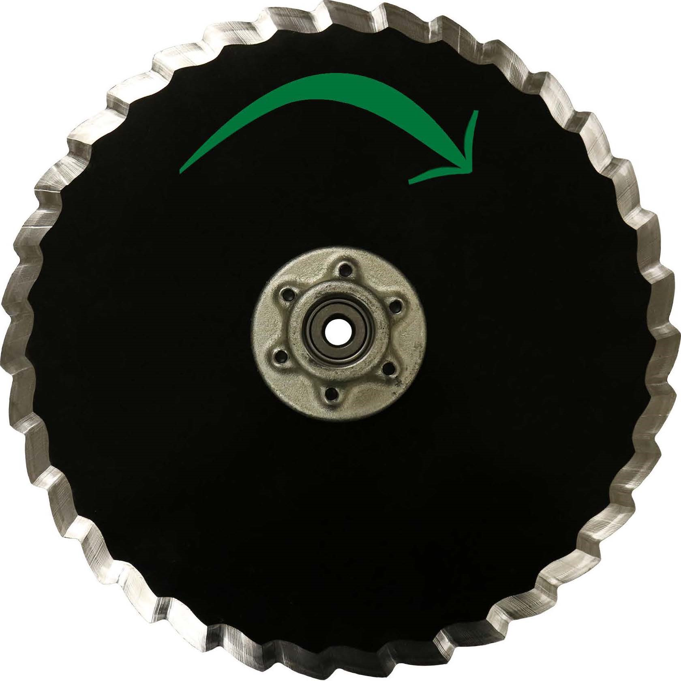
STP Series Installation Instructions
Prescription Tillage Technology, LLC.
103 S Broadway Street
Red Oak, Iowa 51566
712-357-1149
Prescriptiontillage.com

Safety
A brief description of signal words that may be used in this installation brochure:

Note | Used to address safety practices not related to personal injury.
Caution | Indicates a potentially hazardous situation that, if not avoided, may result in minor or moderate injury. It may also be used to alert against unsafe practices.
Warning | Indicates a potentially hazardous situation that, if not avoided, could result in serious injury or death. It may also be used to alert against unsafe practices.
Danger | Indicates an imminently hazardous situation that, if not avoided, will result in serious injury or death. This signal word is to be limited to the most extreme situations.

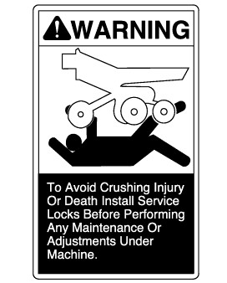 | Danger
Consult your implement and tractor operators manual for correct and safe locking position of the unit in the upward or raised position.
FAILURE MAY RESULT IN PERSONAL INJURY OR DEATH.

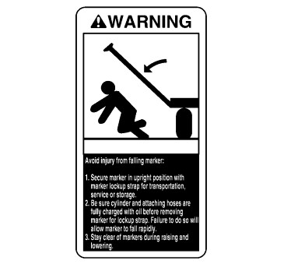 | Warning
 | Servicing machine in the upward or raised position; position locking devices in proper position and or install safety stand to prevent accidental drop or fall and injury.

Warning
When handling blades wear protective foot- wear such as steal toed boots. No open toed shoes.
Warning
Only use hub bosses to rotate STP True- V blades. Do not place fingers between blades during rotation. 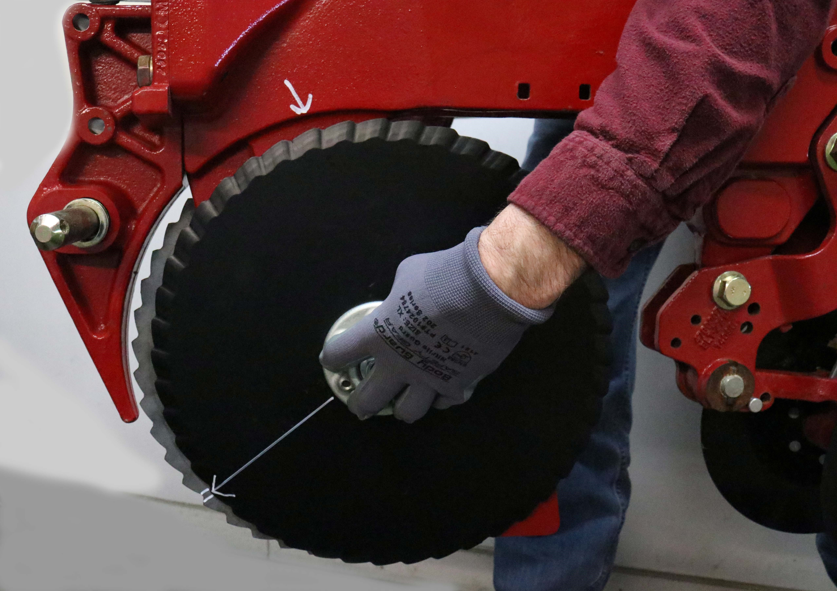
Warning
Blades are sharp, wear leather gloves when handling and installing.
Danger
Do not ride on top of the planter unit, serious injury or death will occur.

STPS True-V Installation Instructions:
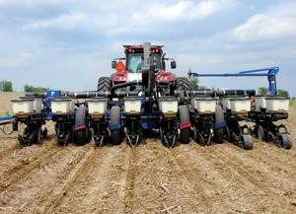
For: Kinze, John Deere, Harvest International, Horsch, and White-Precision:
STP 15.00” Left

STP 14.75"Right

Left side matches matches matches
STP 15.00” Right

STP14.75" Left

Right side matches
s
WARNING: Blades are sharp use leather gloves and use caution.
A. Raise planter off the ground and secure with safety lock and safety stand. B. Remove gauge wheel arms.
- Remove scrapers.
- Remove existing blades.
Note: Blades should be equally spaced on each side of the shank.

Part Number Example: STP0015.00=[OD]000000L=[Side]
E Use 1 ¾ “x 5/8 “R or L hand threaded bolts for installation of double roller bearing hub. WARNING: Left hand side of the unit uses left hand threads. Right hand side of the unit uses right hand threads.

STP Blade Installation; Standing behind the planter
Install the STP 15.00" Left and mate the STP 14.75 Right on the Left row units. Install the STP 15.00" Right and mate the STP Series 14.75" Left on the Right row units.

STPS Blade Installation; Standing behind the planter Install or mate the STPS 15.00" Left with the STPS 15.00" Right on each Row unit.
- When mixing OEM blades and STP series blades; Lower seed depth setting around 1/4" for the STP and 1/8” for the STPS. Inspect seed depth.
- The STP-STPS Series may require more down pressure vs the OEM blades in heavy moist stubble, wheel track compaction and certain soil conditions. PTT recommends 450 lbs of minimum Down pressure capability. Down pressure requirements should be checked periodically.

STP-STPS Series True-V Installation Instructions:

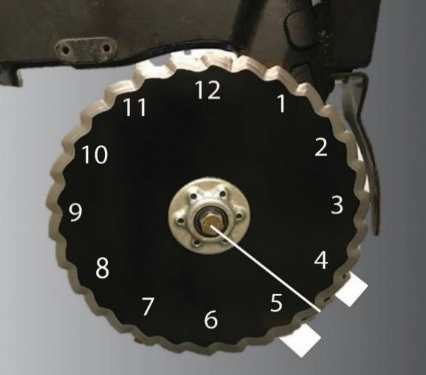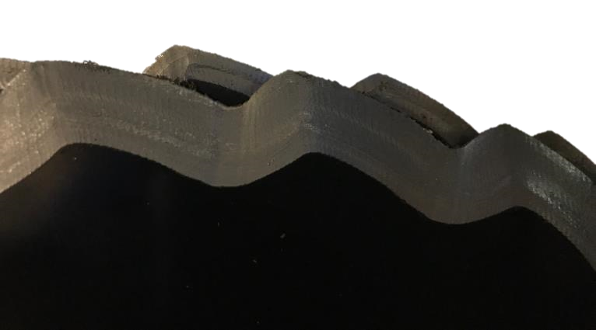
Figure 1 Right Hand Side [Figure 2]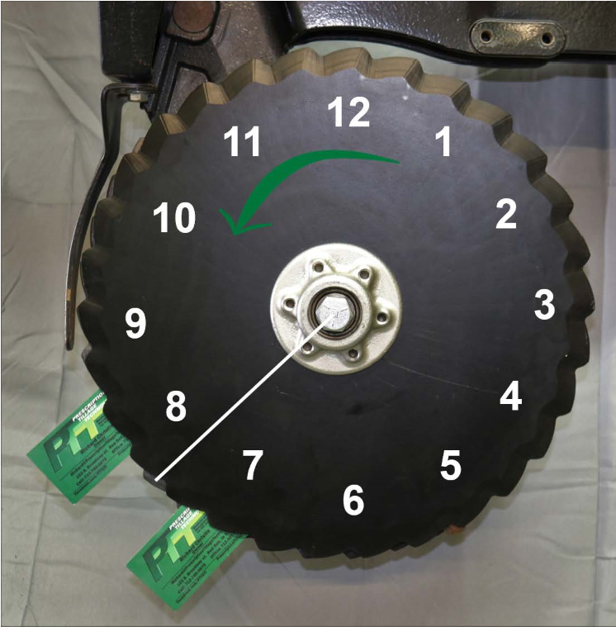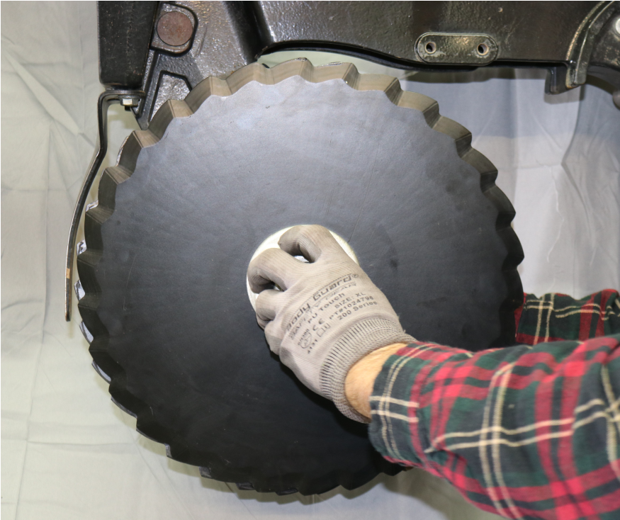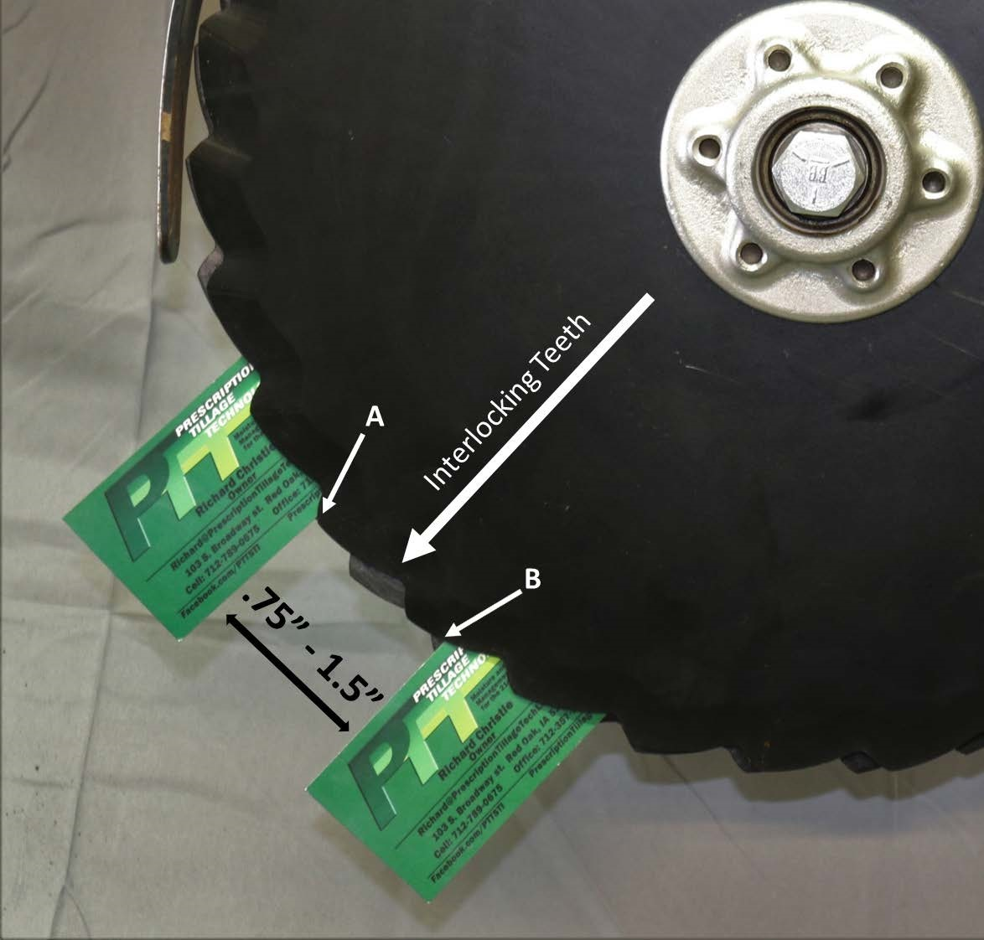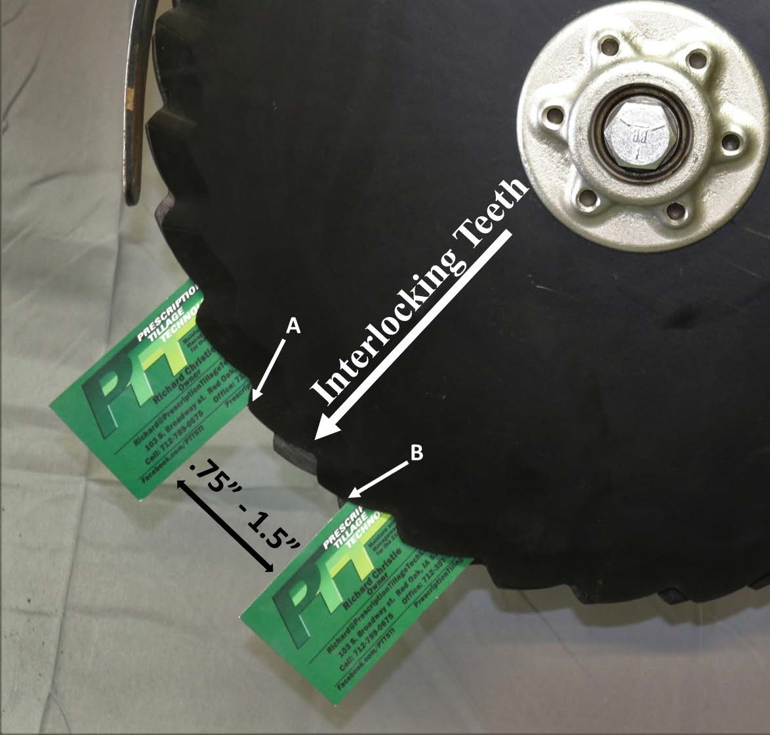 Left hand side Interlocking Teeth
Rotating blade with hub boss
[figure5]

[Figure 3] [Figure 4]

E. Position teeth in interlock contact (Figure 1, 3 and 4), at the 4:30 position (Figure 2) on the right-hand side or 7:30 position (Figure 3 and 4) on the left-hand side. USING TWO BUSINESS CARDS POSITION BLADE MATING CONTACT AT .75"- 1.5” (1.905cm - 3.81cm)(Figure 4). Using hub bosses; (figure 5) Rotate blades in opposing direction with resistance of 2-5 ft-lbs during blade rotation.

Note: Blades have an inside bevel allowing blade mating. Smaller blades rotate faster than larger blades. Out of spec pre-load may cause pre-mature wear. When rotating blades use hub bosses to protect from injury. (figure 5)
F. As blades wear, blades may need to be adjusted to maintain blade contact. Blades should be replaced at 14.25" Outside Diameter. G. Figure 2: Depth wheels should make blade to depth wheel contact at the 4:00-5:00 position, preventing soil build up between blade and depth wheel, lessening row plugging. Reinstall scrapers and gauge wheels assemblies. Lift Gauge wheel assembly 1"- 2" [simulating planting depth]. Pull Gauge wheel assembly outward or away from True V Blade. Rotate Depth wheel in forward direction. Depth wheel should make light or constant contact with True V blade
